Types of Computer Networks

1. Personal Area Network (PAN)

2. Local Area Network (LAN)

3. Wireless LAN (WLAN)

4. Metropolitan Area Network (MAN)

5. Wide Area Network (WAN)

6. Storage Area Network (SAN)

7. Campus Area Network (CAN)

8. Enterprise Private Network (EPN)

9. Virtual Private Network (VPN)

10. Content Delivery Network (CDN)

11. Peer-to-Peer Network (P2P)

12. Client-Server Network

13. Intranet & Extranets

Classification Based on Geographical Area

1. Personal Area Network (PAN)
A PAN is the smallest and most localized network type. PAN offers a network range of 1 to 10 meters from person to device providing communication.Its transmission speed is very high with very easy maintenance and very low cost. PANs are common for quick file transfers, wireless audio, or connecting wearable gadgets.
Examples : Smartphones, laptops, smartwatches, and bluetooth, USBs etc.
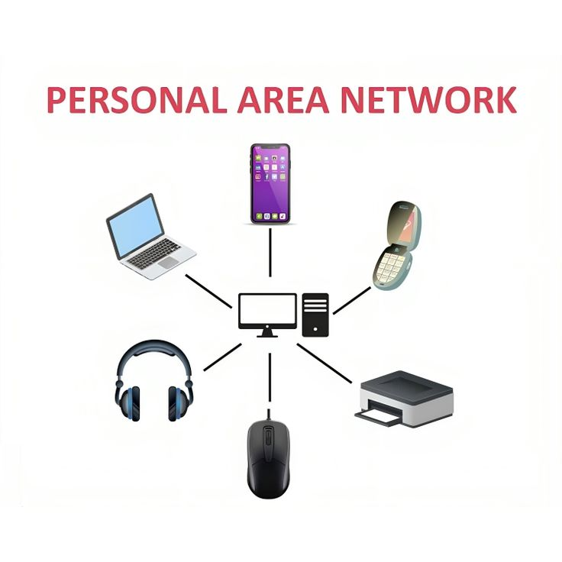

2. Local Area Network (LAN)
A LAN connects computers within a limited area such as a home, office, or laboratory. It offers high-speed communication and is typically owned and managed by a single organization. LANs allow resource sharing such as printers, internal databases, and files. It ranges up to 2km & transmission speed is very high with easy maintenance and low cost.
Examples : Ethernet cables, Wi‑Fi.
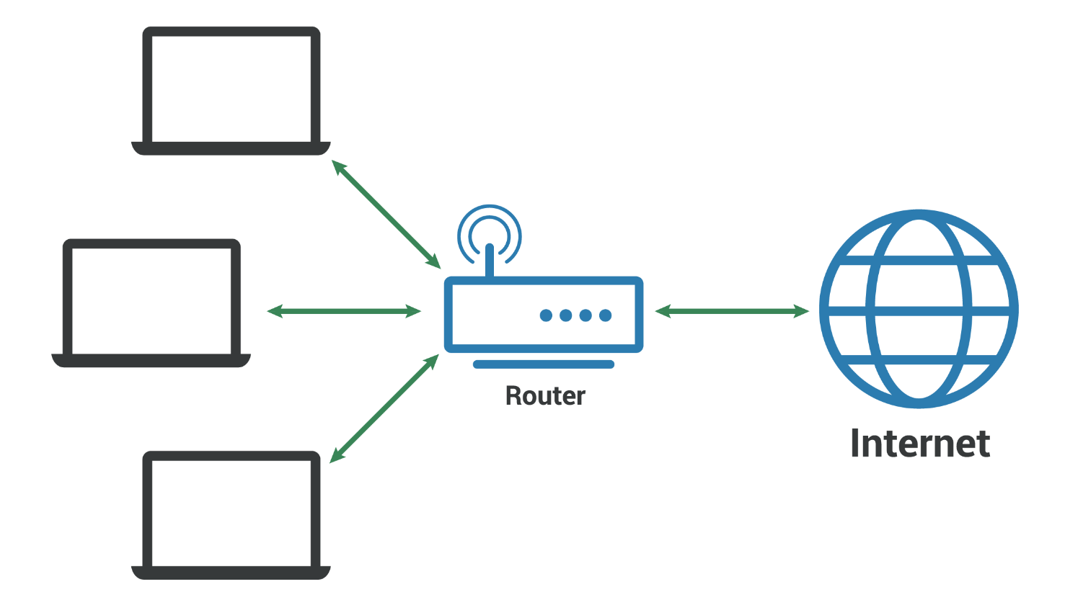

3. Campus Area Network (CAN)
CAN links multiple LANs into one coherent network using high-speed switches and fiber connections. CANs ensure seamless communication and resource sharing across all buildings. CAN mainly use Ethernet technology with a range of a few kilometers. Its transmission speed is very high with a moderate maintenance cost.
Examples : This is a type of computer network that is usually used in places like school, colleges, university, corporate office complex, or military base.
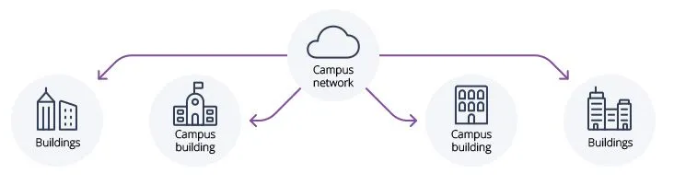4. Metropolitan Area Network (MAN)
A MAN covers a larger geographic area such as a city or large campus. It connects multiple LANs using high‑speed fiber-optic links. Service providers or government organizations usually operate MANs. They are used for city-wide internet services, interconnecting corporate offices, and linking university campuses.
Examples : Internet, Banking Systems, Cloud Services, Corporate Networks.
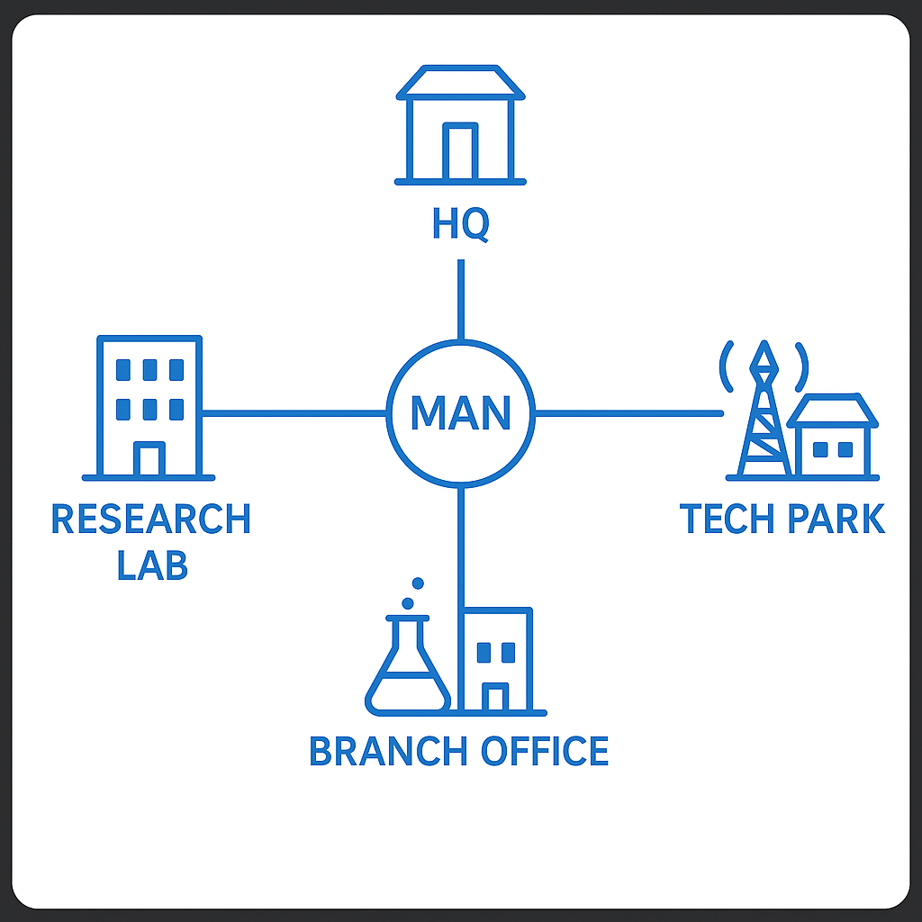

5. Wide Area Network (WAN)
A WAN spans countries or continents and interconnects multiple LANs and MANs. The internet is the largest example of a WAN. WANs rely on leased telecommunication lines, satellite links, and underwater fiber cables. WANs support large-scale enterprise communication and global connectivity.
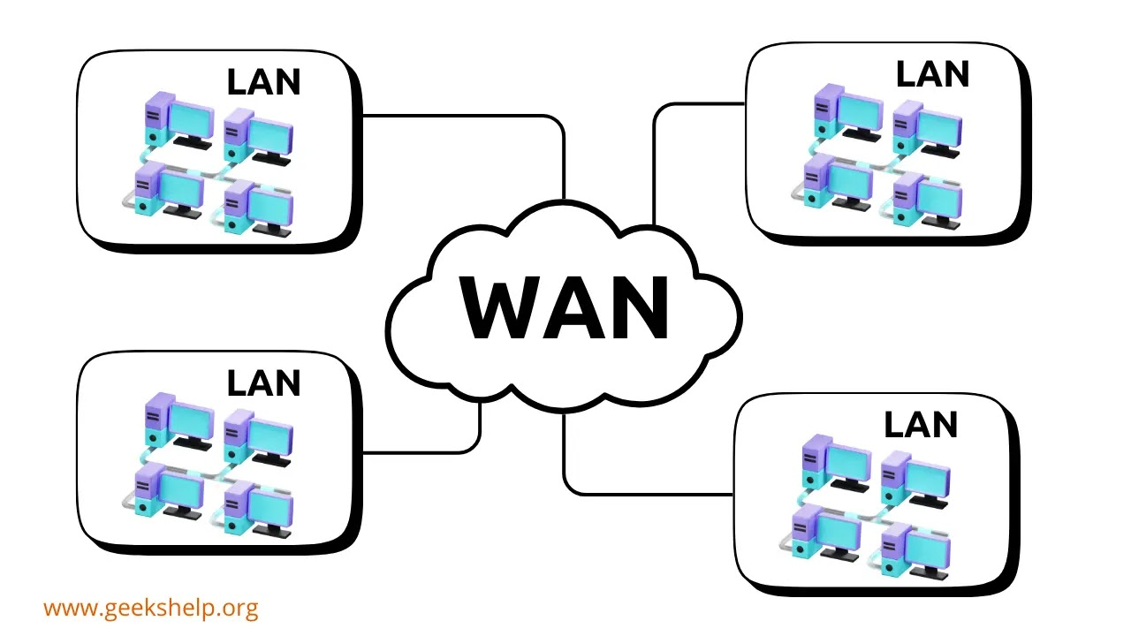

Classification Based on Transmission
Technology

6. Wireless LAN (WLAN)
A WLAN is similar to a LAN but uses wireless communication standards like IEEE 802.11 (Wi‑Fi). It allows mobile devices to join the network without cables. WLANs enable flexibility but require strong security protocols such as WPA2/WPA3 to prevent unauthorized access.
Examples : Wi-Fi.
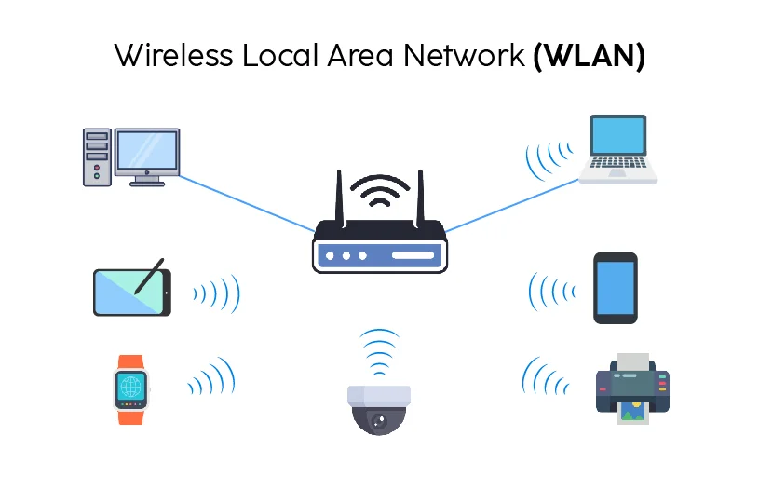

6. Storage Area Network (SAN)
A SAN is a specialized high-speed network that provides block-level storage for servers. It is primarily used in enterprise data centers for storing large volumes of data and ensuring high availability. SANs use protocols like Fibre Channel (FC) and iSCSI. They improve performance, data management, and backup efficiency.
Examples : Fibre Channel SAN (FC-SAN), iSCSI SAN, FCoE SAN.

7. Passive Optical Local Area Network (POLAN)
A POLAN is a type of computer network that is an alternative to a LAN. POLAN uses optical splitters to split an optical signal from a single strand of single-mode optical fiber to multiple signals to distribute users and devices. In short, POLAN is a point to multipoint LAN architecture.
Examples : Tellabs Optical LAN (Tellabs OLAN), Cisco Passive Optical Network (Cisco PON-based LAN), Huawei POLAN Solution, Nokia Optical LAN etc
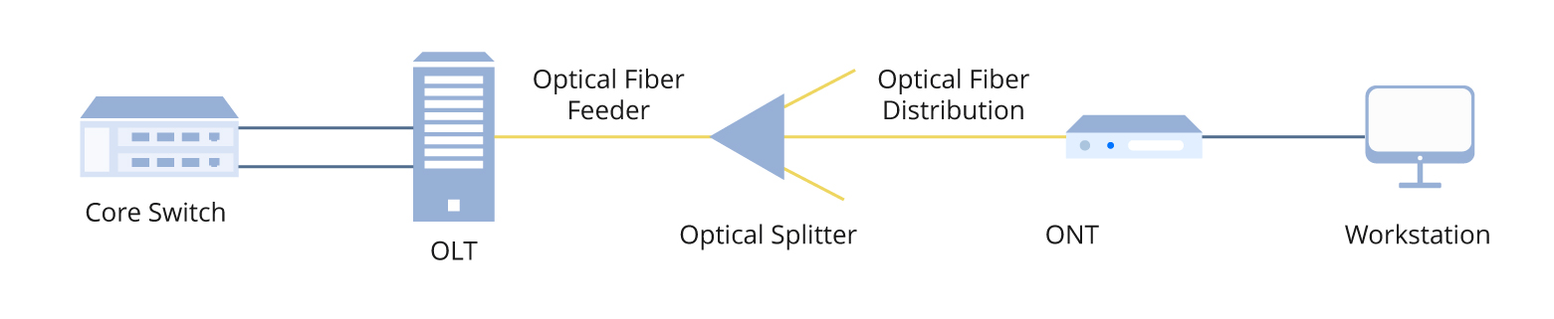

Classification Based on Ownership and Access Control

8. Private Network
These are networks completely owned and managed by a single organization or individual. The owner controls who can connect, what they can do, and how data moves within the network. Since there is no outside access, they are highly secure and reliable, often protected by firewalls and strict policies.

9. Virtual Private Network (VPN)
A VPN enables secure communication over a public network like the internet. It uses encryption protocols (e.g., IPSec, SSL) to protect data transmitted between a user’s device and a remote server. VPNs are widely used for remote work, accessing corporate resources, and browsing securely over public Wi‑Fi
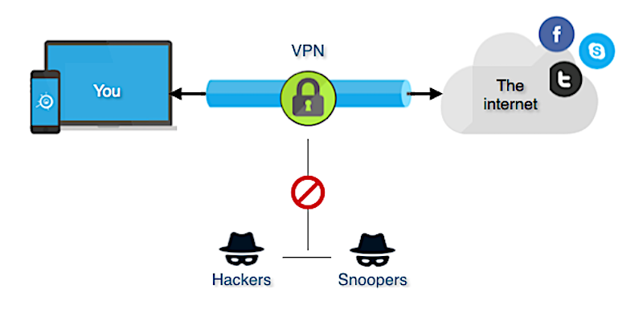.

Miscellaneous

10. Content Delivery Network (CDN)
A CDN is a distributed network of servers placed in different geographic regions to deliver content faster to users. Companies like Netflix, YouTube, and Cloudflare use CDNs to reduce latency and handle large traffic volumes. CDNs replicate content across servers so users receive data from the nearest location.

11. Peer‑to‑Peer Network (P2P)
In a P2P network, each device (peer) can act as both a client and server. No centralized authority controls the data. P2P is used for file sharing, blockchain networks, and distributed computing. It improves redundancy and reduces dependency on a central server.

12. Client‑Server Network
This is the most common architecture where clients request services, and servers provide them. Web browsing, email, and database systems use this model. It supports scalability, centralized management, and security but requires powerful servers.

13. Intranet & Extranet
An intranet is a private internal network accessible only within an organization. It hosts internal tools, dashboards, and knowledge bases. An extranet extends limited access to external partners, vendors, or clients. Both improve collaboration and streamline communication.
IPv4 v/s IPv6
1. IPv4
IPv4 (Internet Protocol version 4) is an addressing system used to identify devices on a network.
IPv4:
- 32-bit address format.
- Written as four decimal numbers (example: 192.168.0.1).
- Total possible addresses: 4.3 billion.
- Uses dotted decimal notation.
- Limited because the internet grew bigger than its capacity.
- Supports NAT due to limited public IPs.
- Example IPv4 types: Public IP, Private IP, Loopback (127.0.0.1), APIPA (169.254.x.x).

2. IPv6:
- 128-bit address format.
- Written in hexadecimal with colons (example: 2001:0db8:85a3::8a2e:0370:7334).
- Total possible addresses: 3.4 × 10^38 (almost unlimited).
- Designed to replace IPv4.
- No need for NAT because every device can have a unique IP.
- Supports auto-configuration and better security (IPSec built-in).
- Simplified routing due to hierarchical structure.

Key Differences:
1. Address Size: IPv4 = 32-bit, IPv6 = 128-bit.
2. Notation: IPv4 uses decimals, IPv6 uses hexadecimal.
3. Number of Addresses: IPv6 provides exponentially more.
4. Security: IPv6 has IPSec built in; IPv4 relies on add-ons.
5. Configuration: IPv6 supports auto-configuration; IPv4 often needs DHCP.
6. NAT Requirement: IPv4 relies heavily on NAT; IPv6 removes the need.

------------------------------------------------------------
Subnet
2. Subnet (Subnetting)
------------------------------------------------------------
A subnet is a smaller part of a large network. Subnetting divides one network into multiple segments to improve efficiency, performance, and security.

Why Create Subnets?
- Reduces network congestion.
- Improves IP management.
- Enhances security by isolating segments.
- Allows grouping of devices logically (e.g., different departments).

Subnet Mask:
A subnet mask defines which portion of an IP address is the Network part and which part is the Host part.

Example:
IP: 192.168.1.50
Subnet Mask: 255.255.255.0
Here:
- Network portion: 192.168.1
- Host portion: .50

CIDR Notation:
Instead of writing full masks (255.255.255.0), CIDR uses a slash number.

Examples:
192.168.1.0/24 → 24 bits for network, 8 bits for hosts
10.0.0.0/8 → huge network
192.168.1.0/30 → very small network (only 2 usable hosts)

How Subnetting Works (Simple):
Network is broken down like rooms inside a house:
- The house = entire network
- Rooms = subnets
- People inside rooms = devices inside each subnet

Effect of Subnet Size:
Larger subnet (e.g., /16): more hosts, less networks.
Smaller subnet (e.g., /28): fewer hosts, more networks.
Network Address Translation (NAT)
Network Address Translation is a method used in routers to map multiple private IP addresses to a single public IP address. This is required because IPv4 addresses are limited.
Why NAT Exists:
- IPv4 only supports 4.3 billion addresses.
- Every device at home or office cannot get a public IP.
- NAT allows private networks (like 192.168.x.x) to access the Internet using one public IP.

Types of NAT:
1. Static NAT:
One private IP mapped to one public IP.
Example: A server that needs the same public identity.

2. Dynamic NAT:
A pool of public IPs is assigned to private IPs as needed.

3. PAT (Port Address Translation):
Also known as NAT Overload.
Many devices share one public IP, separated by port numbers.
Example: A whole home uses one internet IP.

How NAT Works (Simple Explanation):
A router sits between your private network and the internet.
When devices inside the home (like phone, laptop) send traffic to the internet:
- NAT changes their private IPs into the router's public IP.
- NAT keeps track of which internal device requested what data.
- When a response comes back, NAT sends the data to correct device.

Benefits of NAT:
- Saves IPv4 addresses.
- Provides basic security by hiding internal devices.
- Allows multiple users to share one public IP.

Drawbacks of NAT:
- Less needed in IPv6 networks.
- Can break peer-to-peer connections unless port forwarding is used.
- Increases router processing.

------------------------------------------------------------

SUMMARY
------------------------------------------------------------
IPv4 is older, limited, and widely used; IPv6 is newer with huge address capacity. Subnetting divides networks into smaller, manageable parts for efficiency and security. NAT allows multiple devices to share one public IP, compensating for IPv4 limitations.

